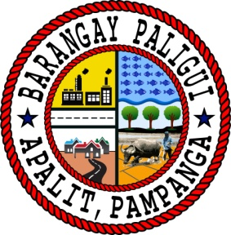Republic of the Philippines

Region III

Province of Pampanga

Municipality of Apalit

**BARANGAY PALIGUI**

*Office of the Sangguniang Kabataan*

**AN EXCERPT FROM THE MINUTES OF THE MEETING DURING THE 7th SANGGUNIANG KABATAAN REGULAR SESSION HELD ON May 12 2024,**

**5:00 P.M. AT BARANGAY PALIGUI SESSION HALL, APALIT, PAMPANGA.**

**Present:**

Hon. Arjay L. Saclao - SK Chairperson/

Presiding Officer

Hon. Paul C. Alfonso - SK Kagawad

Hon. Ervie R. Dizon - SK Kagawad

Hon. Angelo F. Umali - SK Kagawad

Hon. Chin Jean M. Meneses - SK Kagawad

Hon. Ian Jaspher C. Villarico - SK Kagawad

Hon. Michaela Lorine R. Amparo - SK Kagawad

Hon. Karen B. Bautista - SK Kagawad

Mr. Kenneth D. Bautista - SK Secretary

Ms. Angel Mae B. Bautista - SK Treasurer

**Absent:**

*x------------------------------------------------------------------------------------------------------------------x*

**RESOLUTION NO. 01**

**Series of 2024**

**A RESOLUTION TO SUPPLEMENT THE 10% SHARE FOR THE MONTH OF DECEMBER YEAR 2023 FOR THE AMOUNT OF PHP 42,491.10 TO MEET THE BUDGET ON TRAINING EXPENSES FOR THE YEAR 2024**

**WHEREAS,** Section 20 (a) of RA 10742 also known as the Sangguniang Kabataan Reform Act of 2015 states that “ten percent (10%) of the general fund of the barangay shall be set aside for the SK. The Sangguniang Barangay shall appropriate the SK funds in lump sum, which shall be disbursed solely for youth development and empowerment purposes”;

**WHEREAS,** Section 20 (b) of the same law provides that the SK shall have financial independence in its operation, disbursements, and encashment of their fund, income and expenditures;

**WHEREAS,** the SK Annual Budget, which is the financial plan embodying the estimates of income and expenditures of the SK for one (1) fiscal year, shall be prepared in accordance with the approved Annual Barangay Youth Investment Program (ABYIP);

**WHEREAS,** the SK Chairperson, with the assistance of the SK Treasurer, has prepared to use the **10% SHARE FOR THE MONTH OF DECEMBER YEAR 2023** amounting **FORTY-TWO THOUSAND FOUR HUNDRED NINETY-ONE PESOS AND TEN CENTAVOS (PHP 42,491.10)** to meet the budget on training expenses for the year 2024.

**NOW THEREFORE, BE IT RESOLVED, AS IT IS HEREBY RESOLVED BY THE SANGGUNIANG KABATAAN OF BARANGAY PALIGUI, APALIT, PAMPANGA,** to approve this supplemental budget for C.Y. 2024.

**RESOLVED FURTHER.** that copy of this resolution be given to the Local Youth Development Office of Apalit, Pampanga, Municipal Office of the Interior and Local Government, and Municipal Budget Office for their information and record.

x------------------------------------------------------------------------------------------------------------------x

**ADOPTED,** this 12th day of May 2024 at Barangay Paligui, Apalit, Pampanga.

Attested by:

**MR. KENNETH D. BAUTISTA**

SK Secretary

Approved by:

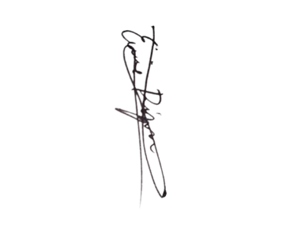**HON. ARJAY L. SACLAO**

SK Chairperson



**HON. PAUL C. ALFONSO HON. ERVIE R. DIZON**

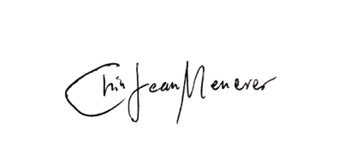SK Kagawad SK Kagawad

**HON. ANGELO F. UMALI HON. CHIN JEAN M. MENESES**

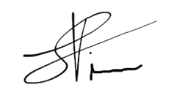SK Kagawad SK Kagawad

**HON. IAN JASPER C. VILLARICO HON. MICHAELA LORINE R. AMPARO**

SK Kagawad SK Kagawad

**HON. KAREN B. BAUTISTA**

SK Kagawad